Spring Boot Interview Questions
Spring Boot is a one-stop Framework to develop Spring applications very easily. I have covered a lot of spring interview questions earlier, this is specifically for spring boot interview questions and answers.
These spring boot interview questions are good for experienced programmers as well as new to spring boot framework.

What is Spring Boot?
In simple words, Spring Boot Framework is Auto-Dependency Resolution, Auto-Configuration, Management EndPoints, Embedded HTTP Servers(Jetty/Tomcat etc.) and Spring Boot CLI
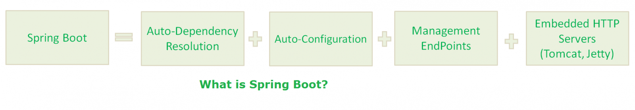
In other words, Spring Boot Framework is Spring Boot Starter, Spring Boot Auto-Configurator, Spring Boot Actuator, Embedded HTTP Servers, and Groovy.
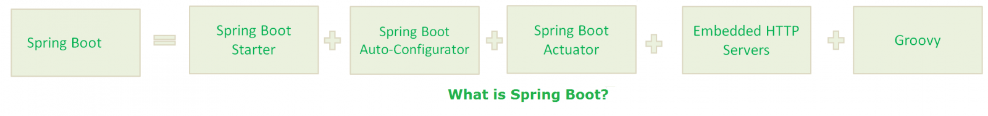
In other words, Spring Boot Framework is Spring Boot CLI.
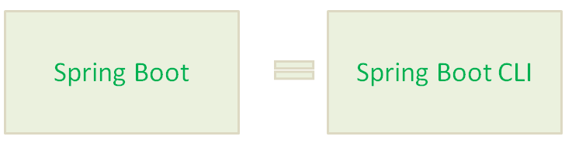
NOTE:-
If you are confused about the last two definitions, please read the rest of the post to make it clear.

Why we need Spring Boot?
- Spring Framework aims to simplify Java Applications Development.
- Spring Boot Framework aims to simplify Spring Development.
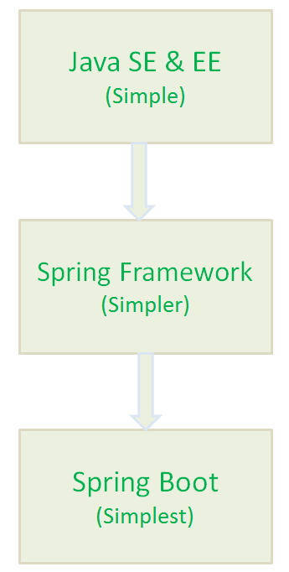

Spring Boot Components
Spring Boot Framework has the following components:
- Spring Boot Starter
- Spring Boot AutoConfigurator
- Spring Boot Actuator
- Spring Boot CLI
- Spring Boot Initilizr

What is Spring Boot Starter?
Spring Boot Starters are just JAR Files. They are used by Spring Boot Framework to provide “Auto-Dependency Resolution”.
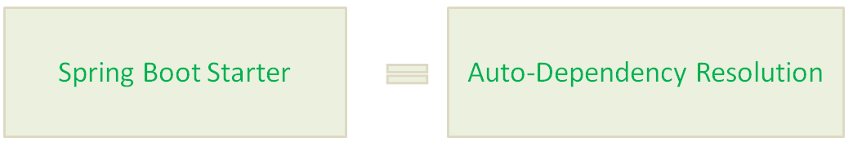

What is Spring Boot AutoConfigurator?
Spring Boot AutoConfigurator is used by Spring Boot Framework to provide “Auto-Configuration”.
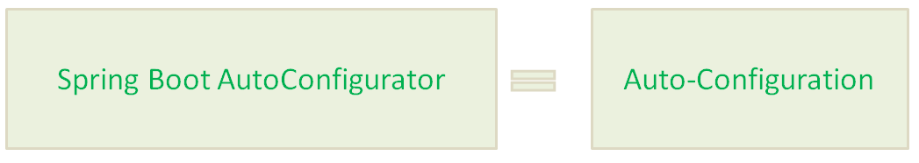

What is Spring Boot Actuator?
Spring Boot Actuator is used by Spring Boot Framework to provide “Management EndPoints” to see Application Internals, Metrics etc.
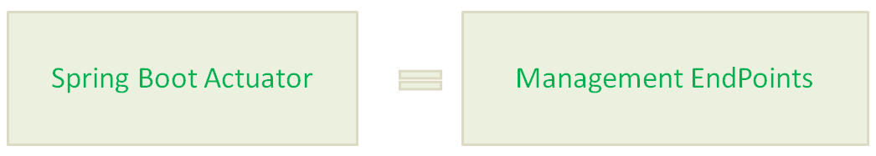

What is Spring Boot CLI?
In simple words, Spring Boot CLI is Auto Dependency Resolution, Auto-Configuration, Management EndPoints, Embedded HTTP Servers(Jetty, Tomcat etc.) and (Groovy, Auto-Imports)
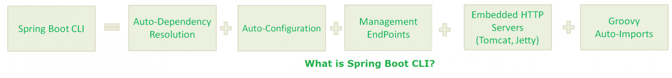
In other words, Spring Boot CLI is Spring Boot Starter, Spring Boot Auto-Configurator, Spring Boot Actuator, Embedded HTTP Servers, and Groovy.
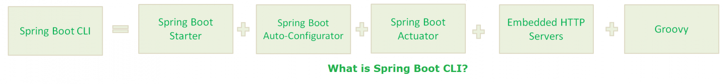
With Spring Boot CLI:
- No Semicolons
- No Public and private access modifiers
- No Imports(Most)
- No “return” statement
- No setters and getters
- No Application class with main() method(It takes care by SpringApplication class).
- No Gradle/Maven builds.
- No separate HTTP Servers.

What is Spring Boot Initilizr?
Spring Boot Initilizr is a Spring Boot tool to bootstrap Spring Boot or Spring Applications very easily.
Spring Boot Initilizr comes in the following forms:
- Spring Boot Initilizr With Web Interface
- Spring Boot Initilizr With IDEs/IDE Plugins
- Spring Boot Initilizr With Spring Boot CLI
- Spring Boot Initilizr With ThirdParty Tools

Why we need Spring Boot Initilizr?
Spring Boot Initilizr simplifies Spring Applications Development by providing initial project structure and build scripts.
- It reduces Development time
- It increases Productivity

Spring Boot With Maven/Gradle?
Spring Boot Framework uses one of the greatest features of Maven/Gradle build tools: “Transitively Dependency Resolution Management”.

What is “Transitively Dependency Resolution Management”?
“Transitively Dependency Resolution Management” means: If we define an “A” dependency in build scripts, “A” is dependent on “B” and “B” is dependent on “C”, That means “A” is also dependent on “C”.
Then Build Tools will download and add all Three Jar files “A”, “B” and “C” to our application classpath.
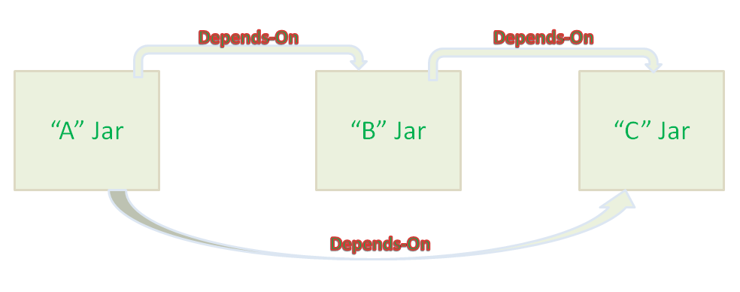
That’s all about Spring Boot interview questions and answers. If you want to learn these concepts in depth, please go through my previous posts one by one. You should also go through official documentation.

What is Microservice Architecture?
Microservice Architecture is an architectural development style which allows building an application as a collection of small autonomous services developed for a business domain.
Let's take an example of e-commerce application developed with microservice architecture. In this example, each microservice is focused on single business capability. Search, Rating & Review and Payment each have their instance (server) and communicate with each other.
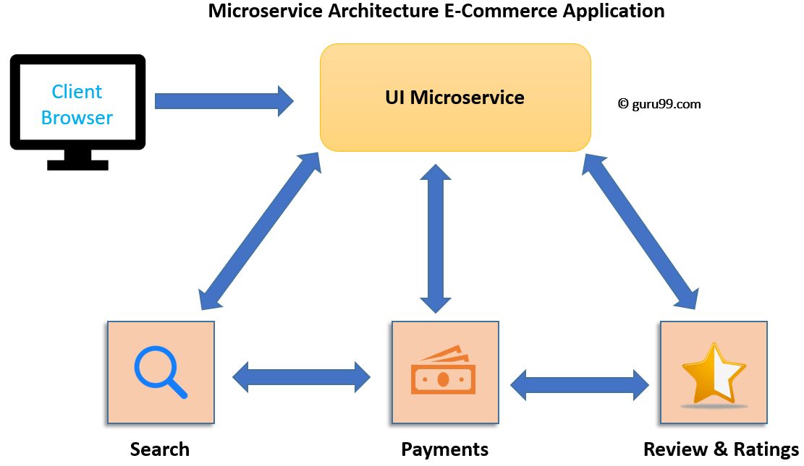Microservices Architecture Example
In this Monolithic Architecture, all the components coalesce into a single module. But, in Microservices Architecture they are spread into individual modules(microservice) which communicate with each other.
The communication between microservices is a stateless communication where each pair of request and response is independent. Hence, Microservices can communicate effortlessly. In the Microservice Architecture, the Data is federated. Each Microservice has its separate data store.

Microservices vs. Monolithic Architecture
Microservices | Monolithic Architecture
Every unit of the entire application should be the smallest, and it should be able to deliver one specific business goal. | A single code base for all business goals
Service Startup is relatively quick | Service startup takes more time
Fault isolation is easy. Even if one service goes down, other can continue to function. | Fault isolation is difficult. If any specific feature is not working, the complete system goes down. In order to handle this issue, the application needs to re-built, re-tested and also re-deployed.
All microservices should be loosely coupled so that changes made in one does not affect the other. | Monolithic architecture is tightly coupled. Changes in one module of code affect the other
Businesses can deploy more resources to services that are generating higher ROI | Since services are not isolated, individual resource allocation not possible
More hardware resources could be allocated to the service that is frequently used. In the e-commerce example above, more number of users check the product listing and search compared to payments. So, more resources could be allocated to the search and product listing microservice. | Application scaling is challenging as well as wasteful.
Microservices always remains consistent and continuously available. | Development tools get overburdened as the process needs to start from the scratch.
Data is federated. This allows individual Microservice to adopt a data model best suited for its needs. | Data is centralized.
Small Focused Teams. Parallel and faster development | Large team and considerable team management effort is required
Change in the data model of one Microservice does not affect other Microservices. | Change in data model affects the entire database
Interacts with other microservices by using well-defined interfaces | Not applicable
Microservices work on the principle that focuses on products, not projects | Put emphasize on the entire project
No cross-dependencies between code bases. You can use different technologies for different Microservices. | One function or program depends on others.

Microservice Challenges
- MicroServices rely on each other, and they will have to communicate with each other.
- Compared to monolithic systems, there are more services to monitor which are developed using different programming languages.
- As it is a distributed system, it is an inherently complex model.
- Different services will have its separate mechanism, resulting in a large amount of memory for an unstructured data.
- Effective management and teamwork required to prevent cascading issues
- Reproducing a problem will be a difficult task when it's gone in one version, and comes back in the latest version.
- Independent Deployment is complicated with Microservices.
- Microservice architecture brings plenty of operations overhead.
- It is difficult to manage application when new services are added to the system
- A wide array of skilled professionals is required to support heterogeneously distributed microservices
- Microservice is costly, as you need to maintain different server space for different business tasks.

Microservice Step:
  - Create a spring boot project using above step
  - Implement swagger
  - Implement docker
  - Docker container orchestration used for find the discovery service
  - Docker Swarm(No auto scaling) or Kubernetes(it have auto scaling)
  - Integrated in CI/CD(continuous integration and continuous deployed using Jenkins)
  - Test wiremock / restAssured and testng to do the testing
  - Hystrix used to find out the fault tolerance

Microservices Tools
1. Wiremock: Testing Microservices
WireMock is a flexible library for stubbing and mocking web services. It can configure the response returned by the HTTP API when it receives a specific request. It is also y used for testing Microservices.
Download link: http://wiremock.org/
2. Docker and Docker Orchestration
Docker is open source project that allows us to create, deploy, and run applications by using containers. By using these containers, developers can run an application as a single package. It allows you to ship libraries and other dependencies in one package.
Download link: https://www.docker.com/
3. Hystrix
Hystrix is a fault tolerance java library. This tool is designed to separate points of access to remote services, systems, and 3rd-party libraries in a distributed environment like Microservices. It improves overall system by isolating the failing services and preventing the cascading effect of failures.
Download Link: https://github.com/Netflix/Hystrix

Best Practices of Microservices Architecture
- Separate data store for each Microservice
- Keep code of a similar level of maturity.
- Separate build for each Micro service
- Always treat- sever as stateless.
Summary
- Microservices is a service-oriented architecture pattern wherein applications are built as a collection of various smallest independent service units.
- Microservice Architecture is an architectural development style that allows building an application as a collection of small autonomous services developed for a business domain.
- Monolithic architecture is like a big container in which all the software components of an application are clubbed into a single package
- In a Microservice, every unit of the entire application should be the smallest, and it should be able to deliver one specific business goal
- In Monolithic architecture, large code base can slow down the entire development process. New releases can take months. Code maintenance is difficult
- Two types of Microservices are 1) Stateless 2) Stateful
- Microservices rely on each other, and they will have to communicate with each other. Helps you to give emphasizes on a specific feature and business needs
- Service-oriented architecture shortly known as SOA is an evolution of distributed computing based on the request or reply design model for synchronous and asynchronous applications
- In SOA, software components are exposed to the outer world for usage in the form of services whereas Micro Service is a part of SOA. It is an implementation of SOA
- Wiremock, Docker, and Hystrix are some popular Microservices Tools

1) Define Web Service?
A web service is a kind of software that is accessible on the Internet. It makes use of the XML messaging system and offers an easy to understand, interface for the end users.
2) What is new in this field for past few years?
The initiation of XML in this field is the advancement that provides web service a single language to communicate in between the RPCs, web services and their directories.
3) Give me an example of real web service?
One example of web services is IBM Web Services browser. You can get it from IBM Alphaworks site. This browser shows various demos related to web services. Basically web services can be used with the help of SOAP, WSDL, and UDDI . All these, provide a plug-and-play interface for using web services such as stock-quote service, a traffic-report service, weather service etc.
4) How you define web service protocol stack?
It is basically set of various protocols that can be used to explore and execute web services. The entire stack has four layers i.e. Service Transport, XML Messaging, Service Description and Service Discovery.
5) Can you define each of these layers of protocol stack?
The Service Transport layer transfer messages between different applications, such as HTTP, SMTP, FTP, and Blocks Extensible Exchange Protocol (BEEP). The XML Messaging layer encodes messages in XML format so that messages can be understood at each end, such as XML-RPC and SOAP. The Service Description layer describes the user interface to a web service, such as WSDL. The Service Discovery layer centralizes services to a common registry and offer simple publish functionality, such as UDDI.
6) Define XML – RPC?
It is a protocol that makes use of XML messages to do Remote Procedure Calls.
7) Define SOAP?
SOAP is an XML based protocol to transfer between computers.
8) Define WSDL?
It means Web Services Description Language. It is basically the service description layer in the web service protocol stock. The Service Description layer describes the user interface to a web service.
9) What kind of security is needed for web services?
The security level for web services should be more than that of what we say Secure Socket Layer (SSL). This level of security can be only achieved from Entrust Secure Transaction Platform. Web services need this level of security to ensure reliable transactions and secure confidential information .
10) Do you have any idea about foundation security services?
As implies from its name, these services are the foundation or basics of integration, authentication, authorization, digital signatures and encryption processes.
11) Define Entrust Identification Service?
Entrust Identification Service comes from the Entrust Security Transaction Platform. This platform allows companies to control the identities that are trusted to perform transactions for Web services transactions.
12) What UDDI means?
UDDI stands for Universal, Description, Discovery, and Integration. It is the discovery layer in the web services protocol stack.
13) Define Entrust Entitlements Service?
This service verifies entities that attempt to access a web service. For Example, the authentication service, the Entitlements Service ensures security in business operations.
14) Define Entrust Privacy Service?
As its name implies, it deals with security and confidentiality. This service encrypts data to ensure that only concerned parties can access the data.
15) What do you mean by PKI?
It means Public-Key Infrastructure.
16) What tools are used to test a web service?
I have used SoapUI for SOAP WS and Firefox poster plugin for RESTFul Services.
17) Differentiate between a SOA and a Web service?
SOA is a design and architecture to implement other services. SOA can be easily implemented using various protocols such as HTTP, HTTPS, JMS, SMTP, RMI, IIOP, RPC etc. While Web service, itself is an implemented technology. In fact one can implement SOA using the web service.
18) Discuss various approaches to develop SOAP based web service?
We can develop SOAP based web service with two different types of approaches such as contract-first and contract-last. In the first approach, the contract is defined first and then the classes are derived from the contract while in the later one, the classes are defined first and then the contract is derived from these classes.
19) If you have to choose one approach, then what will be your choice?
In my point of view, the first approach that is the contract-first approach is more feasible as compared to the second one but still it depends on other factors too.
20) Is there any special application required to access web service?
No, you don't need to install any special application to access web service. You can access web service from any application that supports XML based object request and response.
21) Can you name few free and commercial implementations for web services?
The implementations I know are Apache SOAP, JAX-WS Reference Implementation, JAX-RS Reference Implementation, Metro, Apache CXF, MS.NET and Java 6.
22) Name browser that allows access to web service?
JavaScript XmlHttpRequest object is required to access web service via browsers. The browsers that support this object are Internet Explorer, Safari and Mozilla-based browsers like FireFox.
23) What is REST?
REST stands for Representational State Transfer. REST itself is not a standard, while it uses various standards such as HTTP, URL, XML/HTML/GIF/JPEG (Resource Representations) and text/xml, text/html, image/gif, image/jpeg, etc (MIME Types).
24) How one can provide API to users?
To provide an API to the users, one can easily do this with an "open table". All you need to do is to write open table which is basically an XML schema that point to a web service.
25) Name the various communication channels in web service?
Web service is integrated with three protocols such as HTTP/POST, HTTP/GET, and SOAP. It provides three different communication channels to clients. Client can choose any communication method as per requirements.
26) How can you document web service?
Web services are contemplated as self-documenting because they provide entire information regarding the available methods and parameters used for XML based standard, known as WSDL. One can also provide more information to explain web services via their own WebService and WebMethod attributes.
27) What are the situations, when we need ASP.NET web services?
ASP.NET web services are used when one need to implement three tier architecture in a web service. It allows handy ways to use middle tier components through internet. The main advantage of .NET Web services is that they are capable enough to communicate across firewalls because they use SOAP as transport protocol.
28) What are distributed technologies?
The increasing ratio of distributed applications has raised demand for distributed technologies. It allows segmenting of application units and transferring them to different computers on different networks.
29) Differentiate between web services, CORBA and DCOM?
Web services transfer/receive messages to/from application respectively, via HTTP protocol. It uses XML to encode data.
CORBA and DCOM transfer/receive messages to/from application respectively, via non-standard protocols such as IIOP and RPC.
30) Can you tell few benefits of web services?
The biggest advantage of web service is that is supported by wide variety of platforms. Moreover, in near future, web services may spread its boundary and enhance new methods that will provide ease to clients. The enhancement will not affect the clients, even if they offer old methods and parameters.
31) Can you name some standards used in web services?
The standards used in web services are WSDL (used to create interface definition), SOAP (used to structure data), HTTP (communication channels), DISCO (used to create discovery documents) and UDDI (used to create business registries).
32) Explain in brief, what DISCO is?
DISCO means discovery. It groups the list of interrelated web services. The organization that provides web services, issues a DISCO file on its server and that file contains the links of all the provided web services. This standard is good when client knows the company already. Also it can be used within a local network as well.
33) Explain in brief, what UDDI is?
UDDI (Universal Description, Discovery, and Integration) provides consolidated directory for web services on the internet. Clients use UDDI to find web services as per their business needs. It basically hosts the web services from various companies. In order to share web services, you need to publish it in UDDI.
34) Explain the .NET web services supported data types?
.Net web services uses XML-based standards to transfer/receive information. Thus, .NET web services can only works with data types known by XML schema standard. Like FileSteam, Eventlog etc. are not recognized by the XML schema standards and hence, not supported in web services.
35) How a .NET web service is tested?
ASP.NET uses a test page routinely, when one calls for the URL of .asmx file in any browser. This page shows complete information regarding web services.
36) How a .NET web service is consumed?
Since we know that web services are constructed on XML standards. Therefore, clients need to have complete understanding of XML-based messages to interchange messages. Clients can communicate with web services through .NET framework that offers proxy mechanisms. These proxy mechanisms have detailed information regarding data sharing within web services that can be easily used by the clients.
37) Can you name the two Microsoft solutions for distributed applications?
The two Microsoft solutions for distributed applications are .NET Web Services and .NET Remoting.
38) Differentiate between .NET Web Services and .NET Remoting?
As far as protocol is concerned, .NET Web Service uses HTTP, while, .NET Remoting uses any protocol i.e. TCP/HTTP/SMTP. When it comes to performance, .NET Remoting is comparatively, faster than.NET Web Service. Also, as .NET Web Services are hosted via IIS, therefore, it is far more reliable than the .NET Remoting.
39) Name the components to be published while deploying a Web Service?
The components that need to be published during a web service deployment are Web Application Directory, Webservice.asmx File, Webservice.Disco File, Web.Config File and Bin Directory.
40) What are the steps performed by the client to access a web service?
First of all a web reference to the web service is created by the client in his application. Then a proxy class is generated. After that an object of the proxy class is created and at last, the web service is accessed via that proxy object.
41) How web services are implemented in .NET?
To implement web services in .NET, HTTP handlers are used that interrupt requests to .asmx files.
42) Explain few disadvantages of Response Caching?
Response Caching is useless or incompetent when method accepts extensive amount of values because caching means to store lot of information. Also, if the method depends on external source of information, and that are not provided within the parameters then such methods are bypassed.
43) What is the alternate solution to Response Caching?
One can use Data Caching (System.Web.Caching.Cach) instead of Response Caching.
44) Brief few drawbacks of using GET and POST methods to communicate with the web service?
These methods are less secure and inhibit users to pass structures and objects as arguments. Also, it doesn't allow users to pass ByRef arguments.
45) How can one access a class as a web service?
To access a class as a web service, one should inherit the class from the System.Web.Services.WebService class and qualify the class with the WebService attribute.
46) How can one access the web service class method via internet?
To access web service class method via internet, one should qualify a method with the WebMethod attribute.
47) How a SOAP message is structured?
A SOAP message is consists of SOAP Envelope, SOAP Headers, and SOAP Body.
48) Can you name different kinds of web services?
There are two types of web services in total i.e. SOAP based web service and RESTful web service.
This question is already mentioned earlier.
49) What's different in RESTful web services?
The RESTful web services contains no contract or WSDL file.
50) Give me few reasons to use RESTful web service?
The RESTFul web services are simple to implement and test. It supports various data formats such as XML, JSON etc.
51) Explain what is JAVA web services? What are the methods to create web services?
Java webservices is developed to build and deploy basic web service on JAVA platform.
To create a web services, there are two approaches that are adopted
- Top-down approach
- Top-up approach
52) Explain what is JAXP?
JAXP is a JAVA API for XML processing that enables application to write, read, manipulate and transform XML data. Similarly, to perform other various function there are other Java API's as well like JAX-RPC, JAXM, JAXR, JAXB, etc.
53) Mention the JAXB binding framework?
JAXB binding framework is available in three Java Packages
- xml.bind: This package defines abstract classes and interfaces that are used directly with content classes
- xml.bind.util: This package contains utility classes that may be availed by client applications to manage marshalling, unmarshalling and validation events
- xml.bind.helper: This helper package gives partial implementations for some of the javax.xml.bind interfaces. These APIs are not to be directly used by applications using JAXB architecture
54) Give a simple example of how XML document can be Marshal and Unmarshal in JAVA framework?
Marshalling is the process of converting XML document into Java readable form while UnMarshalling is the reverse process of Marshalling. Let see how Java unmarshals an XML document and then marshals it back
JAXBContext jc= JAXBContext.newInstance ("com.acme.foo");
// unmarshal from foo.xml
Unmarshaller u = jc.createUnmarshaller () ;
FooObject fooObj=
(FooObject)u.unmarshal (new File ("foo.xml") );
// marshal to sytem.out
Marshaller m = jc.createMarshaller ();
m.marshal (fooObj, System.out);
55) Explain what does Marshaller do if jaxb.encoding property is not declared?
By default, the Marshaller will use "UTF-8" if jaxb.encoding property is not declared.
56) Mention what are the types of validation can a JAXB client can perform?
There are two types of JAXB client validation that a JAXB can perform
- Unmarshal Time Validation
- On-Demand Validation
57) Mention what are the three ways to handle the event encountered during the marshal, unmarshal and validate operations?
- Using the default event handler
- Register and Implement a custom event handler
- Use the ValidationEventCollector utility
58) Explain where does JAXB compiler is located?
JAXB schema binding compiler is placed in the <JWSDP_Home>/jaxb/bin directory. In this directory, there are two scripts, xjc.sh (Solaris/Linux) and xjc.bat (Windows).
59) In what cases do you need to customize the default binding?
In some cases, you are required to customize the default binding like
- Creating API documentation for the schema derived JAXB packages, classes, methods and constants
- Giving semantically meaningful customized names for cases that the default XML name-to-Java identifier mapping cannot handle automatically
- Overriding default binding- like specifying that a model group should be attached to a class rather than a list
60) Explain what is Inline Customization?
Customization to JAXB bindings made by means of inline binding declarations in an XML schema file that take the form of <xsd:appinfo> elements embedded in schema <xsd:annotation>elements.
61) Explain what is XML signature?
XML can be used to sign any arbitrary data whether it is a binary or XML. The data is recognized via URIs in one or more reference elements. It is described in one or more forms, like detached, enveloping or enveloped.
62) Explain what is Stax?
Stax stands for Streaming API for XML; it is an API to read and write XML documents, originating from the JAVA programming language.
63) Mention what are the usual XML APIs?
The usual XML APIs includes
- DOM based or Tree based APIs: The whole document is read into memory as a tree structure for random availability by calling application
- Event based APIs: The application registers to get events as entities are encountered within the source document
64) Explain what is Push parsing and Pull parsing?
- Pull Parsing: Streaming pull parsing is referred to a programming model in which a client application calls methods on an XML parsing library, when it needed to communicate with an XML infoset- which means the client will only gets XML data when it is asked for
- Push Parsing: In Push Parsing, the parser pushes parsing events or XML data to the application. In push model, the parser got the hold over the parsing process and the parser calls the implemented handler methods.
65) Explain on which technology does XWS security is based on? List out the options that XWS security provides for securing JAX-RPC applications?
XWS security is based on securing web services build on JAX-RPC and on stand-alone application based on SAAJ. For securing JAX-RPC application, options that XWS security provides are
- XML digital signature
- XML encryption
- Username token verification
- XWS security framework APIs
66) List out the six packages available in XML Digital signature API?
Digital signature API is
- xml.crypto
- xml.crypto.dsig
- xml.crypto.dsig.keyinfo
- xml.crypto.dsig.spec
- xml.crypto.dom
- xml.crypto.dsig.dom
67) Explain what is JAXR?
JAXR is the JAVA programming APIs for Java platform application to access and programmatically interact with various kinds of meta-data registries.
68) Explain what does the JAXR architecture consist of?
JAXR architecture is consists of a JAXR client and JAXR provider.
- JAXR client: It is a client program which uses the JAXR API to use a registry through a JAXR provider
- JAXR provider: It is an implementation of the JAXR API that provide access to a particular registry provider or to a class of registry providers that are built on a common speicifications.
69) Explain what is JAXM messaging models?
There are two types of messaging models for JAXM synchronous and asynchronous
- Synchronous messaging model: In such type of model, client directly communicates with the source. In this, the client will send the request and waits.
- Asynchronous messaging model: In this model, client directs the message to the messaging provider and returns back. Messaging provider then executes the routing of the message to the end source.
70) Explain what is UDDI, DISCO and WSDL?
- UDDI: It means Universal Description, Discovery and I It is the directory that is used to publish and discover public web services
- DISCO: It is commonly known as discovery. It clubs common services together and exposes schemas document of the web services
- WSDL: It stands for web service description language (WSDL). It is used to describe web services. The description includes URL of web services, properties and methods supported by web services, data type it supports and protocol detail it supports

X-Axis Scaling
X-axis scaling is also called as horizontal scaling. In this procedure, the entire application is sub-divided into different horizontal parts. Normally, any web server application can have this type of scaling. Consider a normal MVC architecture that follows horizontal scaling as shown in the following figure.
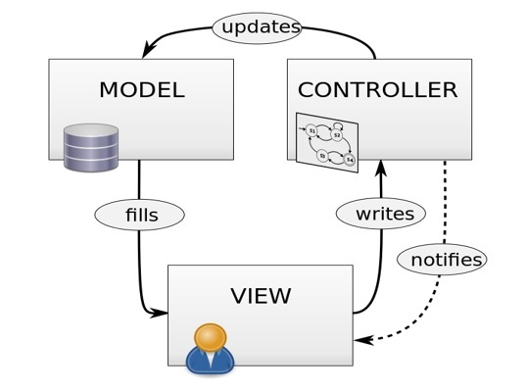
As an example, we can consider any JSP servlet application. In this application, the controller controls every request and it will generate view by communicating with the model whenever necessary. Normally, monolithic applications follow this scaling method. X-Axis scaling is very basic in nature and it is very less time consuming. In this methodology, one software will be scaled depending on its different task that the unit is responsible for. For example, the controller is responsible for controlling the incoming and outgoing request, the view is responsible for representing the business functionality to the users in the browser, while the model is responsible to store our data and it works as the database.

Y-Axis Scaling
Y-axis scaling is also called as a vertical scaling that includes any resource level scaling. Any DBaaS or Hadoop system can be considered to be Y-axis scaled. In this type of scaling, the users request is redirected and restricted by implementing some logic.
Let us consider Facebook as an example. Facebook needs to handle 1.79 million users in every second; hence, controlling the traffic is a huge responsibility of Facebook network engineers. To overcome from any hazard, they follow Y-axis scaling which includes running multiple servers with the same application at the same time. Now in order to control this huge level of traffic, Facebook redirects all the traffic from one region to a specific server, as depicted in the image. This transferring of traffic based on the region is called load balancing in architectural language.
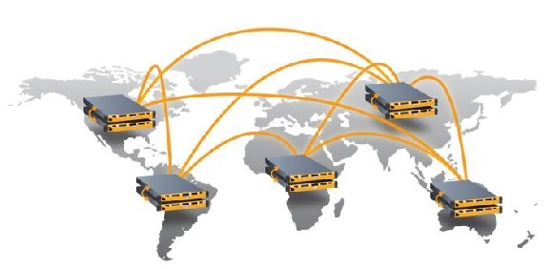
This method of breaking down resources into small independent business units is known as Y-Axis scaling.

Z-Axis Scaling
X- and Y-axis scaling is pretty much easier to understand. However, one application can also be scaled at the business level, which is called as Z-axis scaling. Following is an example of scaling a cab service application in the different verticals of business units.
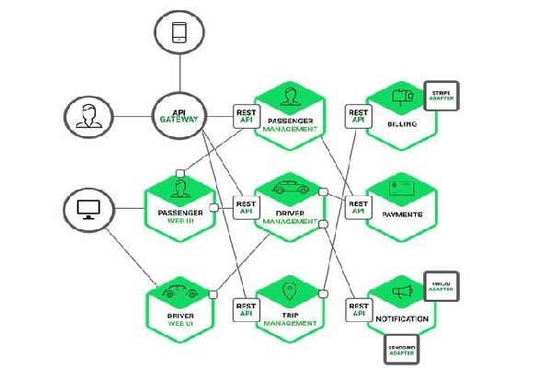

Advantages of Scaling
- Cost − Proper scaling of a software will reduce the cost for maintenance.
- Performance − Due to loose coupling, the performance of a properly scaled software is always better than a non-scaled software.
- Load distribution − Using different technologies, we can easily maintain our server load.
- Reuse − Scalability of a software also increases the usability of the software.

Kafka 101
Kafka Streams is, by deliberate design, tightly integrated with Apache Kafka®: many capabilities of Kafka Streams such as its stateful processing features, its fault tolerance, and its processing guarantees are built on top of functionality provided by Apache Kafka®’s storage and messaging layer. It is therefore important to familiarize yourself with the key concepts of Kafka, notably the sections Getting Started and Design in the Kafka documentation. In particular you should understand:
- The who’s who: Kafka distinguishes producers, consumers, and brokers. In short, producers publish data to Kafka brokers, and consumers read published data from Kafka brokers. Producers and consumers are totally decoupled, and both run outside the Kafka brokers in the perimeter of a Kafka cluster. A Kafka cluster consists of one or more brokers. An application that uses the Kafka Streams API acts as both a producer and a consumer.
- The data: Data is stored in topics. The topic is the most important abstraction provided by Kafka: it is a category or feed name to which data is published by producers. Every topic in Kafka is split into one or more partitions. Kafka partitions data for storing, transporting, and replicating it. Kafka Streams partitions data for processing it. In both cases, this partitioning enables elasticity, scalability, high performance, and fault tolerance.
- Parallelism: Partitions of Kafka topics, and especially their number for a given topic, are also the main factor that determines the parallelism of Kafka with regards to reading and writing data. Because of the tight integration with Kafka, the parallelism of an application that uses the Kafka Streams API is primarily depending on Kafka’s parallelism.
Stream
A stream is the most important abstraction provided by Kafka Streams: it represents an unbounded, continuously updating data set, where unbounded means “of unknown or of unlimited size”. Just like a topic in Kafka, a stream in the Kafka Streams API consists of one or more stream partitions.
A stream partition is an, ordered, replayable, and fault-tolerant sequence of immutable data records, where a data record is defined as a key-value pair.
Stream Processing Application
A stream processing application is any program that makes use of the Kafka Streams library. In practice, this means it is probably “your” application. It may define its computational logic through one or more processor topologies.
Your stream processing application doesn’t run inside a broker. Instead, it runs in a separate JVM instance, or in a separate cluster entirely.
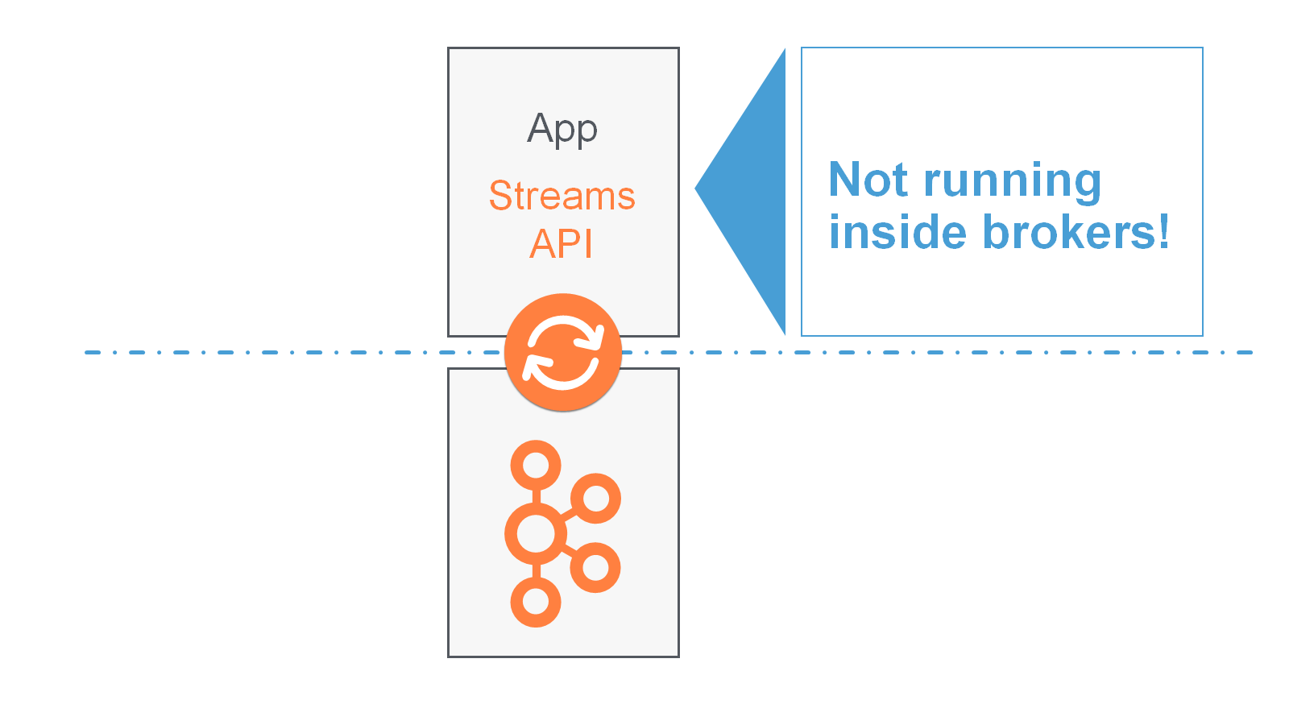
An application instance is any running instance or “copy” of your application. Application instances are the primary means to elasticly scale and parallelize your application, and they also contribute to making it fault-tolerant. For example, you may need the power of ten machines to handle the incoming data load of your application; here, you could opt to run ten instances of your application, one on each machine, and these instances would automatically collaborate on the data processing – even as new instances/machines are added or existing ones removed during live operation.
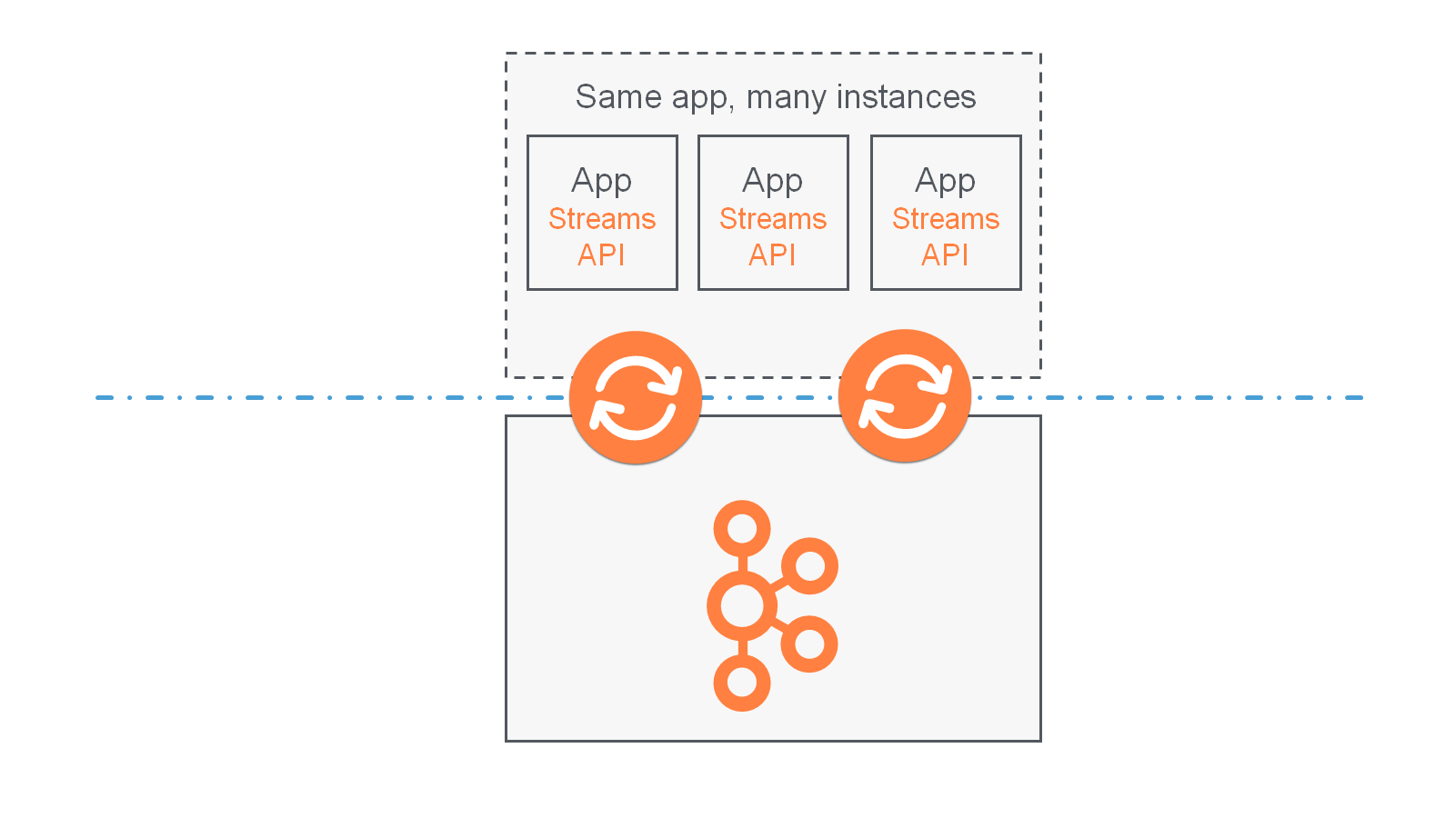
Processor Topology
A processor topology or simply topology defines the computational logic of the data processing that needs to be performed by a stream processing application. A topology is a graph of stream processors (nodes) that are connected by streams (edges). Developers can define topologies either via the low-level Processor API or via the Kafka Streams DSL, which builds on top of the former.
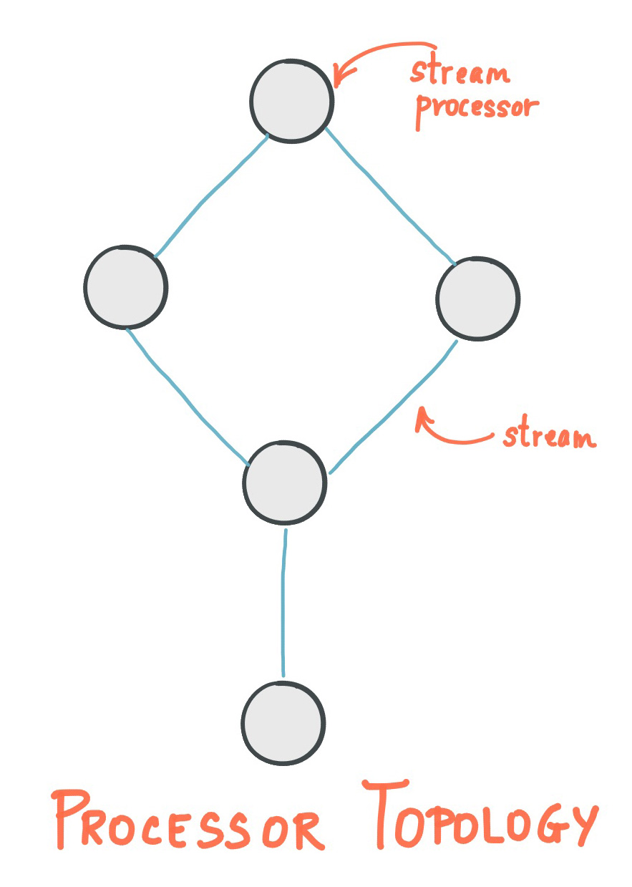
The Architecture documentation describes topologies in more detail.
Stream Processor
A stream processor is a node in the processor topology as shown in the diagram of section Processor Topology. It represents a processing step in a topology, i.e. it is used to transform data. Standard operations such as map or filter, joins, and aggregations are examples of stream processors that are available in Kafka Streams out of the box. A stream processor receives one input record at a time from its upstream processors in the topology, applies its operation to it, and may subsequently produce one or more output records to its downstream processors.
Kafka Streams provides two APIs to define stream processors:
- The declarative, functional DSL is the recommended API for most users – and notably for starters – because most data processing use cases can be expressed in just a few lines of DSL code. Here, you typically use built-in operations such as map and filter.
- The imperative, lower-level Processor API provides you with even more flexibility than the DSL but at the expense of requiring more manual coding work. Here, you can define and connect custom processors as well as directly interact with state stores.
Stateful Stream Processing
Some stream processing applications don’t require state – they are stateless – which means the processing of a message is independent from the processing of other messages. Examples are when you only need to transform one message at a time, or filter out messages based on some condition.
In practice, however, most applications require state – they are stateful – in order to work correctly, and this state must be managed in a fault-tolerant manner. Your application is stateful whenever, for example, it needs to join, aggregate, or window its input data. Kafka Streams provides your application with powerful, elastic, highly scalable, and fault-tolerant stateful processing capabilities.
Duality of Streams and Tables
When implementing stream processing use cases in practice, you typically need both streams and also databases. An example use case that is very common in practice is an e-commerce application that enriches an incoming stream of customer transactions with the latest customer information from a database table. In other words, streams are everywhere, but databases are everywhere, too.
Any stream processing technology must therefore provide first-class support for streams and tables. Kafka’s Streams API provides such functionality through its core abstractions for streams and tables, which we will talk about in a minute. Now, an interesting observation is that there is actually a close relationship between streams and tables, the so-called stream-table duality. And Kafka exploits this duality in many ways: for example, to make your applications elastic, to support fault-tolerant stateful processing, or to run Interactive Queries against your application’s latest processing results. And, beyond its internal usage, the Kafka Streams API also allows developers to exploit this duality in their own applications.
Before we discuss concepts such as aggregations in Kafka Streams we must first introduce tables in more detail, and talk about the aforementioned stream-table duality. Essentially, this duality means that a stream can be viewed as a table, and a table can be viewed as a stream.
Note
We intentionally keep the following explanations simple and thus skip the discussion of compound keys, multisets, and so on.
A simple form of a table is a collection of key-value pairs, also called a map or associative array. Such a table may look as follows:
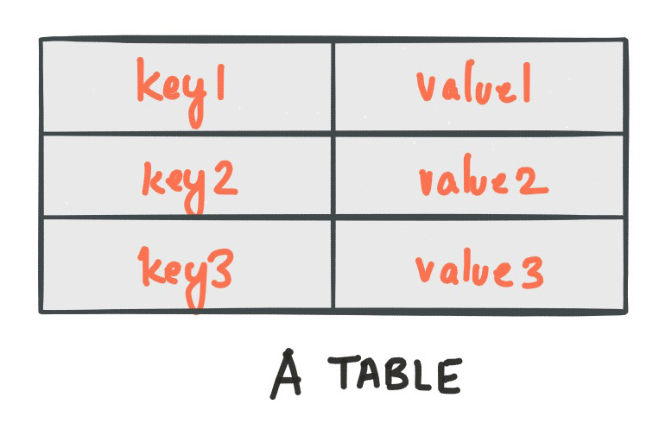
The stream-table duality describes the close relationship between streams and tables.
- Stream as Table: A stream can be considered a changelog of a table, where each data record in the stream captures a state change of the table. A stream is thus a table in disguise, and it can be easily turned into a “real” table by replaying the changelog from beginning to end to reconstruct the table. Similarly, aggregating data records in a stream will return a table. For example, we could compute the total number of pageviews by user from an input stream of pageview events, and the result would be a table, with the table key being the user and the value being the corresponding pageview count.
- Table as Stream: A table can be considered a snapshot, at a point in time, of the latest value for each key in a stream (a stream’s data records are key-value pairs). A table is thus a stream in disguise, and it can be easily turned into a “real” stream by iterating over each key-value entry in the table.
Let’s illustrate this with an example. Imagine a table that tracks the total number of pageviews by user (first column of diagram below). Over time, whenever a new pageview event is processed, the state of the table is updated accordingly. Here, the state changes between different points in time – and different revisions of the table – can be represented as a changelog stream (second column).
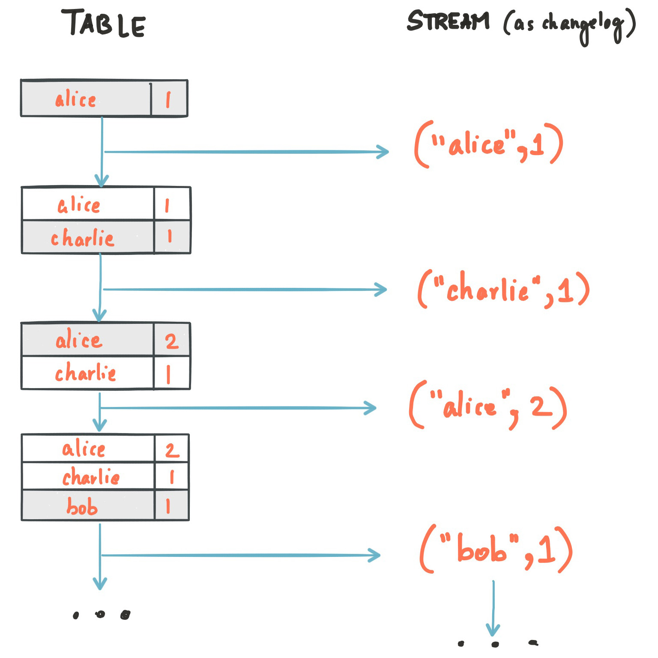
Because of the stream-table duality, the same stream can be used to reconstruct the original table (third column):
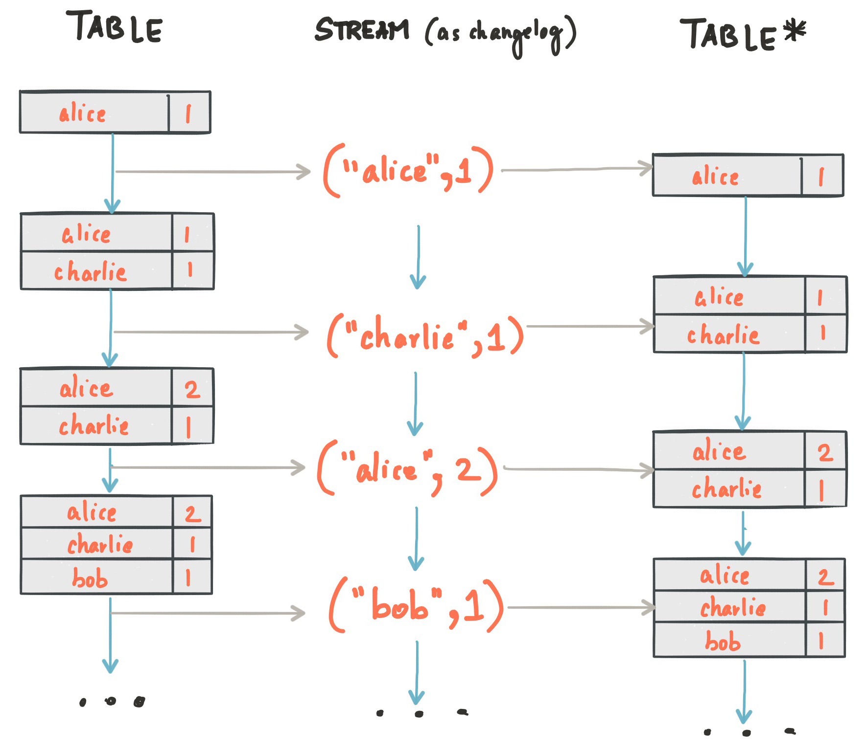
The same mechanism is used, for example, to replicate databases via change data capture (CDC) and, within Kafka Streams, to replicate its so-called state stores across machines for fault tolerance. The stream-table duality is such an important concept for stream processing applications in practice that Kafka Streams models it explicitly via the KStream and KTable abstractions, which we describe in the next sections.
KStream
Note
Only the Kafka Streams DSL has the notion of a KStream.
A KStream is an abstraction of a record stream, where each data record represents a self-contained datum in the unbounded data set. Using the table analogy, data records in a record stream are always interpreted as an “INSERT” – think: adding more entries to an append-only ledger – because no record replaces an existing row with the same key. Examples are a credit card transaction, a page view event, or a server log entry.
To illustrate, let’s imagine the following two data records are being sent to the stream:
("alice", 1) --> ("alice", 3)
If your stream processing application were to sum the values per user, it would return 4 for alice. Why? Because the second data record would not be considered an update of the previous record. Compare this behavior of KStream to KTable below, which would return 3 for alice.
KTable
Note
Only the Kafka Streams DSL has the notion of a KTable.
A KTable is an abstraction of a changelog stream, where each data record represents an update. More precisely, the value in a data record is interpreted as an “UPDATE” of the last value for the same record key, if any (if a corresponding key doesn’t exist yet, the update will be considered an INSERT). Using the table analogy, a data record in a changelog stream is interpreted as an UPSERT aka INSERT/UPDATE because any existing row with the same key is overwritten. Also, null values are interpreted in a special way: a record with a null value represents a “DELETE” or tombstone for the record’s key.
To illustrate, let’s imagine the following two data records are being sent to the stream:
("alice", 1) --> ("alice", 3)
If your stream processing application were to sum the values per user, it would return 3 for alice. Why? Because the second data record would be considered an update of the previous record. Compare this behavior of KTable with the illustration for KStream above, which would return 4 for alice.
Note
Effects of Kafka’s log compaction: Another way of thinking about KStream and KTable is as follows: If you were to store a KTable into a Kafka topic, you’d probably want to enable Kafka’s log compaction feature, e.g. to save storage space.
However, it would not be safe to enable log compaction in the case of a KStream because, as soon as log compaction would begin purging older data records of the same key, it would break the semantics of the data. To pick up the illustration example again, you’d suddenly get a 3 for alice instead of a 4 because log compaction would have removed the ("alice", 1) data record. Hence log compaction is perfectly safe for a KTable (changelog stream) but it is a mistake for a KStream (record stream).
We have already seen an example of a changelog stream in the section Duality of Streams and Tables. Another example are change data capture (CDC) records in the changelog of a relational database, representing which row in a database table was inserted, updated, or deleted.
KTable also provides an ability to look up current values of data records by keys. This table-lookup functionality is available through join operations (see also Joining in the Developer Guide) as well as through Interactive Queries.
GlobalKTable
Note
Only the Kafka Streams DSL has the notion of a GlobalKTable.
Like a KTable, a GlobalKTable is an abstraction of a changelog stream, where each data record represents an update.
A GlobalKTable differs from a KTable in the data that they are being populated with, i.e. which data from the underlying Kafka topic is being read into the respective table. Slightly simplified, imagine you have an input topic with 5 partitions. In your application, you want to read this topic into a table. Also, you want to run your application across 5 application instances for maximum parallelism.
- If you read the input topic into a KTable, then the “local” KTable instance of each application instance will be populated with data from only 1 partition of the topic’s 5 partitions.
- If you read the input topic into a GlobalKTable, then the local GlobalKTable instance of each application instance will be populated with data from all partitions of the topic.
GlobalKTable provides the ability to look up current values of data records by keys. This table-lookup functionality is available through join operations (see also Joining in the Developer Guide) and Interactive Queries.
Benefits of global tables:
- More convenient and/or efficient joins: Notably, global tables allow you to perform star joins, they support “foreign-key” lookups (i.e., you can lookup data in the table not just by record key, but also by data in the record values), and they are more efficient when chaining multiple joins. Also, when joining against a global table, the input data does not need to be co-partitioned.
- Can be used to “broadcast” information to all the running instances of your application.
Downsides of global tables:
- Increased local storage consumption compared to the (partitioned) KTable because the entire topic is tracked.
- Increased network and Kafka broker load compared to the (partitioned) KTable because the entire topic is read.
Time
A critical aspect in stream processing is the notion of time, and how it is modeled and integrated. For example, some operations such as Windowing are defined based on time boundaries.
Kafka Streams supports the following notions of time:
event-time
The point in time when an event or data record occurred (that is, was originally created by the source). Achieving event-time semantics typically requires embedding timestamps in the data records at the time a data record is being produced.
- Example: If the event is a geo-location change reported by a GPS sensor in a car, then the associated event-time would be the time when the GPS sensor captured the location change.
processing-time
The point in time when the event or data record happens to be processed by the stream processing application (that is, when the record is being consumed). The processing-time may be milliseconds, hours, days, etc. later than the original event-time.
- Example: Imagine an analytics application that reads and processes the geo-location data reported from car sensors to present it to a fleet management dashboard. Here, processing-time in the analytics application might be milliseconds or seconds (such as for real-time pipelines based on Kafka and Kafka Streams) or hours (such as for batch pipelines based on Apache Hadoop or Apache Spark) after event-time.
ingestion-time
The point in time when an event or data record is stored in a topic partition by a Kafka broker. Ingestion-time is similar to event-time, as a timestamp gets embedded in the data record itself. The difference is that the timestamp is generated when the record is appended to the target topic by the Kafka broker, not when the record is created at the source. Ingestion-time may approximate event-time reasonably well if we assume that the time difference between creation of the record and its ingestion into Kafka is sufficiently small, where “sufficiently” depends on the specific use case. Thus, ingestion-time may be a reasonable alternative for use cases where event-time semantics are not possible, perhaps because the data producers don’t embed timestamps (such as with older versions of Kafka’s Java producer client) or the producer cannot assign timestamps directly (for example, does not have access to a local clock).
Timestamps
Kafka Streams assigns a timestamp to every data record via so-called timestamp extractors. These per-record timestamps describe the progress of a stream with regards to time (although records may be out-of-order within the stream) and are leveraged by time-dependent operations such as joins. We call it the event-time of the application to differentiate with the wall-clock-time when this application is actually executing. Event-time is also used to synchronize multiple input streams within the same application.
Concrete implementations of timestamp extractors may retrieve or compute timestamps based on the actual contents of data records such as an embedded timestamp field to provide event-time or ingestion-time semantics, or use any other approach such as returning the current wall-clock time at the time of processing, thereby yielding processing-time semantics to stream processing applications. Developers can thus enforce different notions/semantics of time depending on their business needs.
Finally, whenever a Kafka Streams application writes records to Kafka, then it will also assign timestamps to these new records. The way the timestamps are assigned depends on the context:
- When new output records are generated via directly processing some input record, output record timestamps are inherited from input record timestamps directly.
- When new output records are generated via periodic functions, the output record timestamp is defined as the current internal time of the stream task.
- For aggregations, the timestamp of the resulting update record will be that of the latest input record that triggered the update.
Other aspects of time
Tip
Know your time: When working with time you should also make sure that additional aspects of time such as time zones and calendars are correctly synchronized – or at least understood and traced – throughout your stream data pipelines. It often helps, for example, to agree on specifying time information in UTC or in Unix time (such as seconds since the epoch). You should also not mix topics with different time semantics.
Aggregations
An aggregation operation takes one input stream or table, and yields a new table by combining multiple input records into a single output record. Examples of aggregations are computing counts or sum.
In the Kafka Streams DSL, an input stream of an aggregation operation can be a KStream or a KTable, but the output stream will always be a KTable. This allows Kafka Streams to update an aggregate value upon the late arrival of further records after the value was produced and emitted. When such late arrival happens, the aggregating KStream or KTable emits a new aggregate value. Because the output is a KTable, the new value is considered to overwrite the old value with the same key in subsequent processing steps.
Joins
A join operation merges two input streams and/or tables based on the keys of their data records, and yields a new stream/table.
The join operations available in the Kafka Streams DSL differ based on which kinds of streams and tables are being joined; for example, KStream-KStream joins versus KStream-KTable joins.
Windowing
Windowing lets you control how to group records that have the same key for stateful operations such as aggregations or joins into so-called windows. Windows are tracked per record key.
Windowing operations are available in the Kafka Streams DSL. When working with windows, you can specify a grace period for the window that indicates when window results are final. This grace period controls how long Kafka Streams will wait for out-of-order (“late-arriving”) data records for a window. If a record arrives after the grace period of a window has passed (i.e., record.ts > window-end-time + grace-period), the record is discarded and will not be processed in that window.
Out-of-order records are always possible in the real world and your applications must account for them properly. The system’s time semantics determine how out-of-order records are handled. For processing-time, the semantics are “when the record is being processed”, which means that the notion of out-of-order records is not applicable. Similarly, for ingestion-time, the broker assigns timestamps in ascending order based on topic append order; the timestamp indicates ingestion-time only. Out-of-order records can only be considered for event-time semantics, where timestamps are set by producers specifically to indicate event-time. If two producers write to the same topic partition, there is no guarantee on the event append order.
Kafka Streams is able to properly handle out-of-order records for the relevant time semantics (event-time).
Tip
grace period vs. retention time
The grace period supersedes retention time as a more specific means of defining the amount of time a window should allow for out-of-order events after the window ends. Grace period relates directly to usage of final results for a window and is also a lower bound on retention time.
Retention time is still configurable, but as a lower-level property of the window store. You might choose to retain events for a long time (the default is one day) to support, for example, Interactive Queries even over final windows or even indefinitely on remote, distributed systems with large storage capacity. On the other hand, you might retain events for a short time for an in-memory implementation.
Interactive Queries
Interactive Queries allow you to treat the stream processing layer as a lightweight embedded database, and to directly query the latest state of your stream processing application. You can do this without having to first materialize that state to external databases or external storage.
Interactive Queries simplify the architecture and lead to more application-centric architectures.
The following diagram juxtapose two architectures: the first does not use Interactive Queries whereas the second architecture does. It depends on the concrete use case to determine which of these architectures is a better fit – the important takeaway is that Kafka Streams and Interactive Queries give you the flexibility to pick and to compose the right one, rather than limiting you to just a single way.
Tip
Best of both worlds: Of course you also have the option to run hybrid architectures where, for example, your application may be queried interactively but at the same time also shares some of its results with external systems (e.g. via Kafka Connect).
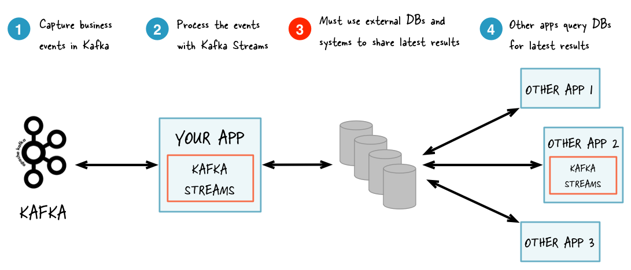
Without Interactive Queries: increased complexity and heavier footprint of architecture.
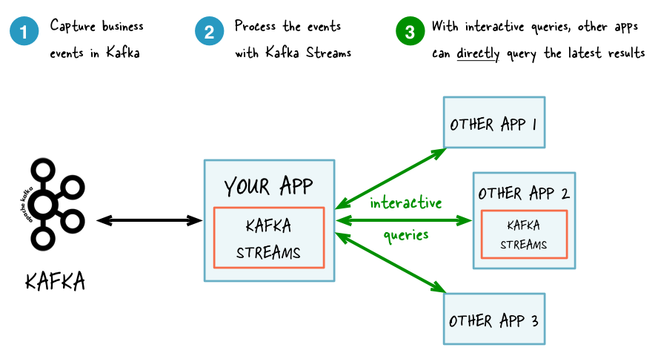
With Interactive Queries: simplified, more application-centric architecture.
Here are some use case examples for applications that benefit from Interactive Queries:
- Real-time monitoring: A front-end dashboard that provides threat intelligence (e.g., web servers currently under attack by cyber criminals) can directly query a Kafka Streams application that continuously generates the relevant information by processing network telemetry data in real-time.
- Video gaming: A Kafka Streams application continuously tracks location updates from players in the gaming universe. A mobile companion app can then directly query the Kafka Streams application to show the current location of a player to friends and family, and invite them to come along. Similarly, the game vendor can use the data to identify unusual hotspots of players, which may indicate a bug or an operational issue.
- Risk and fraud: A Kafka Streams application continuously analyzes user transactions for anomalies and suspicious behavior. An online banking application can directly query the Kafka Streams application when a user logs in to deny access to those users that have been flagged as suspicious.
- Trend detection: A Kafka Streams application continuously computes the latest top charts across music genres based on user listening behavior that is collected in real-time. Mobile or desktop applications of a music store can then interactively query for the latest charts while users are browsing the store.
For more information, see the Developer Guide.
Processing Guarantees
Kafka Streams supports at-least-once and exactly-once processing guarantees.
At-least-once semantics
Records are never lost but may be redelivered. If your stream processing application fails, no data records are lost and fail to be processed, but some data records may be re-read and therefore re-processed. At-least-once semantics is enabled by default (processing.guarantee="at_least_once") in your Streams configuration.
Exactly-once semantics
Records are processed once. Even if a producer sends a duplicate record, it is written to the broker exactly once. Exactly-once stream processing is the ability to execute a read-process-write operation exactly one time. All of the processing happens exactly once, including the processing and the materialized state created by the processing job that is written back to Kafka. To enable exactly-once semantics, set processing.guarantee="exactly_once" in your Streams configuration.
When publishing a record with exactly-once semantics enabled, a write is not considered successful until it is acknowledged, and a commit is made to “finalize” the write. After a published record is acknowledged, it cannot be lost as long as a broker that replicates the partition that the record is written to remains “alive”. If a producer attempts to publish a record and experiences a network error, it cannot determine whether this error happened before or after the record was acknowledged. If a producer fails to receive a response that a record was acknowledged, it will resend the record.
Using exactly-once, producers are configured for idempotent writes. This ensures that a retry on a send record does not result in duplicates, and each record is written to the log exactly once. With exactly-once, multiple records are grouped into a single transaction, and so either all or none of the records are committed.
All Kafka replicas have the same log with the same offsets and the consumer controls its position in this log. But if the consumer fails, and the topic partition needs to be taken over by another process, the new process must choose an appropriate starting position.
When the consumer reads records, it processes the records, and saves its position. There is a possibility that the consumer process crashes after processing records but before saving its position. In this case, when the new process takes over the first few records it receives will already have been processed. This corresponds to the “at-least-once” semantics in the case of consumer failure.
The consumer’s position is stored as a record in a topic. Using exactly-once semantics, a single transaction writes the offset and sends the processed data to the output topics. If the transaction is aborted, the consumer’s position will revert to its old value and the produced data on the output topics will not be visible to other consumers, depending on their “isolation level.” In the default “read_uncommitted” isolation level, all records are visible to consumers even if they were part of an aborted transaction. In the “read_committed” isolation level, the consumer will only return records from transactions that were committed, and any records that were not part of a transaction.
For more information, see the blog post Exactly-once Semantics are Possible: Here’s How Kafka Does it.
Out-of-Order Handling
Besides the guarantee that each record will be processed exactly-once, another challenge issue that many stream processing application will face is how to handle out-of-order data that may impact their business logic. In Kafka Streams, there are two causes that could potentially result in out-of-order data arrivals with respect to their timestamps:
- Within a topic partition, a record’s timestamp may not be monotonically increasing along with their offsets. Since Kafka Streams will always try to process records following the offset order, it can cause records with larger timestamps (but smaller offsets) to be processed earlier than records with smaller timestamps (but larger offsets) in the same topic-partition.
- A stream task may be processing multiple topic partitions, and if users configure the application to not wait for all partitions to contain some buffered data and pick from the partition with the smallest timestamp to process the next record, then later on when some records are fetched for other topic partitions, their timestamps may be smaller than those processed records, effectively causing older records to be processed after the newer records.
For stateless operations, out-of-order data will not impact processing logic since only one record is considered at a time, without looking into the history of past processed records; for stateful operations such as aggregations and joins, however, out-of-order data could cause the processing logic to be incorrect. If users want to handle such out-of-order data, generally they need to allow their applications to wait for longer time while bookkeeping their states during the wait time, i.e. making trade-off decisions between latency, cost, and correctness. In Kafka Streams, users can configure their window operators for windowed aggregations to achieve such trade-offs (details can be found in the Developer Guide).

1. What is Kafka?
Wikipedia defines Kafka as “an open-source message broker project developed by the Apache Software Foundation written in Scala and is a distributed publish-subscribe messaging system.

Kafka Salient Features
Feature | Description
High Throughput | Support for millions of messages with modest hardware
Scalability | Highly scalable distributed systems with no downtime
Replication | Messages are replicated across the cluster to provide support for multiple subscribers and balances the consumers in case of failures
Durability | Provides support for persistence of message to disk
Stream Processing | Used with real-time streaming applications like Apache Spark & Storm
Data Loss | Kafka with proper configurations can ensure zero data loss

2. List the various components in Kafka.
The four major components of Kafka are:
- Topic – a stream of messages belonging to the same type
- Producer – that can publish messages to a topic
- Brokers – a set of servers where the publishes messages are stored
- Consumer – that subscribes to various topics and pulls data from the brokers.

3. Explain the role of the offset.
Messages contained in the partitions are assigned a unique ID number that is called the offset. The role of the offset is to uniquely identify every message within the partition.

4. What is a Consumer Group?
Consumer Groups is a concept exclusive to Kafka. Every Kafka consumer group consists of one or more consumers that jointly consume a set of subscribed topics.

5. What is the role of the ZooKeeper?
Kafka uses Zookeeper to store offsets of messages consumed for a specific topic and partition by a specific Consumer Group.

6. Is it possible to use Kafka without ZooKeeper?
No, it is not possible to bypass Zookeeper and connect directly to the Kafka server. If, for some reason, ZooKeeper is down, you cannot service any client request.

7. Explain the concept of Leader and Follower.
Every partition in Kafka has one server which plays the role of a Leader, and none or more servers that act as Followers. The Leader performs the task of all read and write requests for the partition, while the role of the Followers is to passively replicate the leader. In the event of the Leader failing, one of the Followers will take on the role of the Leader. This ensures load balancing of the server.

8. What roles do Replicas and the ISR play?
Replicas are essentially a list of nodes that replicate the log for a particular partition irrespective of whether they play the role of the Leader. On the other hand, ISR stands for In-Sync Replicas. It is essentially a set of message replicas that are synced to the leaders.

9. Why are Replications critical in Kafka?
Replication ensures that published messages are not lost and can be consumed in the event of any machine error, program error or frequent software upgrades.

10. If a Replica stays out of the ISR for a long time, what does it signify?
It means that the Follower is unable to fetch data as fast as data accumulated by the Leader.

11. What is the process for starting a Kafka server?
Since Kafka uses ZooKeeper, it is essential to initialize the ZooKeeper server, and then fire up the Kafka server.
- To start the ZooKeeper server: > bin/zookeeper-server-start.sh config/zookeeper.properties
- Next, to start the Kafka server: > bin/kafka-server-start.sh config/server.properties

12. How do you define a Partitioning Key?
Within the Producer, the role of a Partitioning Key is to indicate the destination partition of the message. By default, a hashing-based Partitioner is used to determine the partition ID given the key. Alternatively, users can also use customized Partitions.

13. In the Producer, when does QueueFullException occur?
QueueFullException typically occurs when the Producer attempts to send messages at a pace that the Broker cannot handle. Since the Producer doesn’t block, users will need to add enough brokers to collaboratively handle the increased load.

14. Explain the role of the Kafka Producer API.
The role of Kafka’s Producer API is to wrap the two producers – kafka.producer.SyncProducer and the kafka.producer.async.AsyncProducer. The goal is to expose all the producer functionality through a single API to the client.

15. What is the main difference between Kafka and Flume?
Even though both are used for real-time processing, Kafka is scalable and ensures message durability.

Quickstart
This tutorial assumes you are starting fresh and have no existing Kafka or ZooKeeper data. Since Kafka console scripts are different for Unix-based and Windows platforms, on Windows platforms use bin\windows\ instead of bin/, and change the script extension to .bat.

Step 1: Download the code
Download the 2.3.0 release and un-tar it.
1  2 | > tar -xzf kafka_2.12-2.3.0.tgz  > cd kafka_2.12-2.3.0

Step 2: Start the server
Kafka uses ZooKeeper so you need to first start a ZooKeeper server if you don't already have one. You can use the convenience script packaged with kafka to get a quick-and-dirty single-node ZooKeeper instance.
1  2  3 | > bin/zookeeper-server-start.sh config/zookeeper.properties  [2013-04-22 15:01:37,495] INFO Reading configuration from: config/zookeeper.properties (org.apache.zookeeper.server.quorum.QuorumPeerConfig)  ...
Now start the Kafka server:
1  2  3  4 | > bin/kafka-server-start.sh config/server.properties  [2013-04-22 15:01:47,028] INFO Verifying properties (kafka.utils.VerifiableProperties)  [2013-04-22 15:01:47,051] INFO Property socket.send.buffer.bytes is overridden to 1048576 (kafka.utils.VerifiableProperties)  ...

Step 3: Create a topic
Let's create a topic named "test" with a single partition and only one replica:
1 | > bin/kafka-topics.sh --create --bootstrap-server localhost:9092 --replication-factor 1 --partitions 1 --topic test
We can now see that topic if we run the list topic command:
1  2 | > bin/kafka-topics.sh --list --bootstrap-server localhost:9092  test
Alternatively, instead of manually creating topics you can also configure your brokers to auto-create topics when a non-existent topic is published to.

Step 4: Send some messages
Kafka comes with a command line client that will take input from a file or from standard input and send it out as messages to the Kafka cluster. By default, each line will be sent as a separate message.
Run the producer and then type a few messages into the console to send to the server.
1  2  3 | > bin/kafka-console-producer.sh --broker-list localhost:9092 --topic test  This is a message  This is another message

Step 5: Start a consumer
Kafka also has a command line consumer that will dump out messages to standard output.
1  2  3 | > bin/kafka-console-consumer.sh --bootstrap-server localhost:9092 --topic test --from-beginning  This is a message  This is another message
If you have each of the above commands running in a different terminal then you should now be able to type messages into the producer terminal and see them appear in the consumer terminal.
All of the command line tools have additional options; running the command with no arguments will display usage information documenting them in more detail.

Step 6: Setting up a multi-broker cluster
So far we have been running against a single broker, but that's no fun. For Kafka, a single broker is just a cluster of size one, so nothing much changes other than starting a few more broker instances. But just to get feel for it, let's expand our cluster to three nodes (still all on our local machine).
First we make a config file for each of the brokers (on Windows use the copy command instead):
1  2 | > cp config/server.properties config/server-1.properties  > cp config/server.properties config/server-2.properties
Now edit these new files and set the following properties:
1  2  3  4  5  6  7  8  9 | config/server-1.properties:  broker.id=1  listeners=PLAINTEXT://:9093  log.dirs=/tmp/kafka-logs-1  config/server-2.properties:  broker.id=2  listeners=PLAINTEXT://:9094  log.dirs=/tmp/kafka-logs-2
The broker.id property is the unique and permanent name of each node in the cluster. We have to override the port and log directory only because we are running these all on the same machine and we want to keep the brokers from all trying to register on the same port or overwrite each other's data.
We already have Zookeeper and our single node started, so we just need to start the two new nodes:
1  2  3  4 | > bin/kafka-server-start.sh config/server-1.properties &  ...  > bin/kafka-server-start.sh config/server-2.properties &  ...
Now create a new topic with a replication factor of three:
1 | > bin/kafka-topics.sh --create --bootstrap-server localhost:9092 --replication-factor 3 --partitions 1 --topic my-replicated-topic
Okay but now that we have a cluster how can we know which broker is doing what? To see that run the "describe topics" command:
1  2  3 | > bin/kafka-topics.sh --describe --bootstrap-server localhost:9092 --topic my-replicated-topic  Topic:my-replicated-topic PartitionCount:1 ReplicationFactor:3 Configs:  Topic: my-replicated-topic Partition: 0 Leader: 1 Replicas: 1,2,0 Isr: 1,2,0
Here is an explanation of output. The first line gives a summary of all the partitions, each additional line gives information about one partition. Since we have only one partition for this topic there is only one line.
- "leader" is the node responsible for all reads and writes for the given partition. Each node will be the leader for a randomly selected portion of the partitions.
- "replicas" is the list of nodes that replicate the log for this partition regardless of whether they are the leader or even if they are currently alive.
- "isr" is the set of "in-sync" replicas. This is the subset of the replicas list that is currently alive and caught-up to the leader.
Note that in my example node 1 is the leader for the only partition of the topic.
We can run the same command on the original topic we created to see where it is:
1  2  3 | > bin/kafka-topics.sh --describe --bootstrap-server localhost:9092 --topic test  Topic:test PartitionCount:1 ReplicationFactor:1 Configs:  Topic: test Partition: 0 Leader: 0 Replicas: 0 Isr: 0
So there is no surprise there—the original topic has no replicas and is on server 0, the only server in our cluster when we created it.
Let's publish a few messages to our new topic:
1  2  3  4  5 | > bin/kafka-console-producer.sh --broker-list localhost:9092 --topic my-replicated-topic  ...  my test message 1  my test message 2  ^C
Now let's consume these messages:
1  2  3  4  5 | > bin/kafka-console-consumer.sh --bootstrap-server localhost:9092 --from-beginning --topic my-replicated-topic  ...  my test message 1  my test message 2  ^C
Now let's test out fault-tolerance. Broker 1 was acting as the leader so let's kill it:
1  2  3 | > ps aux | grep server-1.properties  7564 ttys002 0:15.91 /System/Library/Frameworks/JavaVM.framework/Versions/1.8/Home/bin/java...  > kill -9 7564
On Windows use:
1  2  3  4 | > wmic process where "caption = 'java.exe' and commandline like '%server-1.properties%'" get processid  ProcessId  6016  > taskkill /pid 6016 /f
Leadership has switched to one of the followers and node 1 is no longer in the in-sync replica set:
1  2  3 | > bin/kafka-topics.sh --describe --bootstrap-server localhost:9092 --topic my-replicated-topic  Topic:my-replicated-topic PartitionCount:1 ReplicationFactor:3 Configs:  Topic: my-replicated-topic Partition: 0 Leader: 2 Replicas: 1,2,0 Isr: 2,0
But the messages are still available for consumption even though the leader that took the writes originally is down:
1  2  3  4  5 | > bin/kafka-console-consumer.sh --bootstrap-server localhost:9092 --from-beginning --topic my-replicated-topic  ...  my test message 1  my test message 2  ^C

Step 7: Use Kafka Connect to import/export data
Writing data from the console and writing it back to the console is a convenient place to start, but you'll probably want to use data from other sources or export data from Kafka to other systems. For many systems, instead of writing custom integration code you can use Kafka Connect to import or export data.
Kafka Connect is a tool included with Kafka that imports and exports data to Kafka. It is an extensible tool that runs connectors, which implement the custom logic for interacting with an external system. In this quickstart we'll see how to run Kafka Connect with simple connectors that import data from a file to a Kafka topic and export data from a Kafka topic to a file.
First, we'll start by creating some seed data to test with:
1 | > echo -e "foo\nbar" > test.txt
Or on Windows:
1  2 | > echo foo> test.txt  > echo bar>> test.txt
Next, we'll start two connectors running in standalone mode, which means they run in a single, local, dedicated process. We provide three configuration files as parameters. The first is always the configuration for the Kafka Connect process, containing common configuration such as the Kafka brokers to connect to and the serialization format for data. The remaining configuration files each specify a connector to create. These files include a unique connector name, the connector class to instantiate, and any other configuration required by the connector.
1 | > bin/connect-standalone.sh config/connect-standalone.properties config/connect-file-source.properties config/connect-file-sink.properties
These sample configuration files, included with Kafka, use the default local cluster configuration you started earlier and create two connectors: the first is a source connector that reads lines from an input file and produces each to a Kafka topic and the second is a sink connector that reads messages from a Kafka topic and produces each as a line in an output file.
During startup you'll see a number of log messages, including some indicating that the connectors are being instantiated. Once the Kafka Connect process has started, the source connector should start reading lines from test.txt and producing them to the topic connect-test, and the sink connector should start reading messages from the topic connect-test and write them to the file test.sink.txt. We can verify the data has been delivered through the entire pipeline by examining the contents of the output file:
1  2  3 | > more test.sink.txt  foo  bar
Note that the data is being stored in the Kafka topic connect-test, so we can also run a console consumer to see the data in the topic (or use custom consumer code to process it):
1  2  3  4 | > bin/kafka-console-consumer.sh --bootstrap-server localhost:9092 --topic connect-test --from-beginning  {"schema":{"type":"string","optional":false},"payload":"foo"}  {"schema":{"type":"string","optional":false},"payload":"bar"}  ...
The connectors continue to process data, so we can add data to the file and see it move through the pipeline:
1 | > echo Another line>> test.txt
You should see the line appear in the console consumer output and in the sink file.

Step 8: Use Kafka Streams to process data
Kafka Streams is a client library for building mission-critical real-time applications and microservices, where the input and/or output data is stored in Kafka clusters. Kafka Streams combines the simplicity of writing and deploying standard Java and Scala applications on the client side with the benefits of Kafka's server-side cluster technology to make these applications highly scalable, elastic, fault-tolerant, distributed, and much more. This quickstart example will demonstrate how to run a streaming application coded in this library.

